Proposal for Differentiating between Inputs and Outputs for Safety Properties in FSP
Andrew McVeigh, 13/12/06

Consider the FSP for a service component, and also for a client component using that service.

deterministic Client = (call.tx -> return.rx -> Client).
deterministic Service = (call.rx -> return.tx -> Service).

I have explicitly separated out calls versus returns, and message receives (rx) from sends (tx) to handle the 4 possible cases. The FSP for each service looks like:

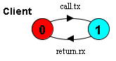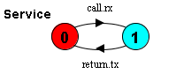

When composing, I match up calls with returns and tx with rx. If two clients are connected to a single service, two call.rx calls can occur in succession on the same service leading to a violation of the service protocol. I wish to detect these errors by amending the Service FSP with transitions to the error state for unwanted received calls (call.rx).

Ideally I’d express this as a safety property and compose the service with the client(s), ensuring that no bad transitions can occur. But if I do that, I get the following property FSPs:

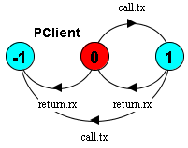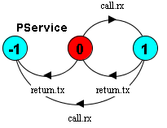

When I compose even a single client and service, I get unwanted transitions to the error state:

||Composition = (PClient || PService) / {call.rx / call.tx, return.tx / return.rx}.
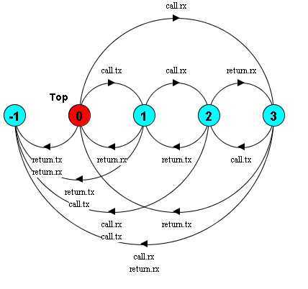
As an example, the transition of 0 to ERROR is notionally caused by the receipt of a return.rx message sent from the client to the service, received as return.tx. This will never happen however, as a return is never sent spontaneously from the client.

What I think I need is the ability to restrict the alphabet for generating error transitions in safety properties to received calls on a service. If I could use something like:

property ||PService =Service using {call.rx}

to generate the following, then I could detect the unwanted calls successfully.

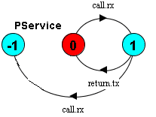

A facility like this would allow me to detect unwanted calls when composing together components in a system.

Proposal
Allow the alphabet to be restricted when forming error transitions for safety properties. To my mind, what I want to express is really still a safety property and should be expressed as such.

